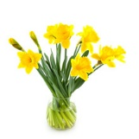
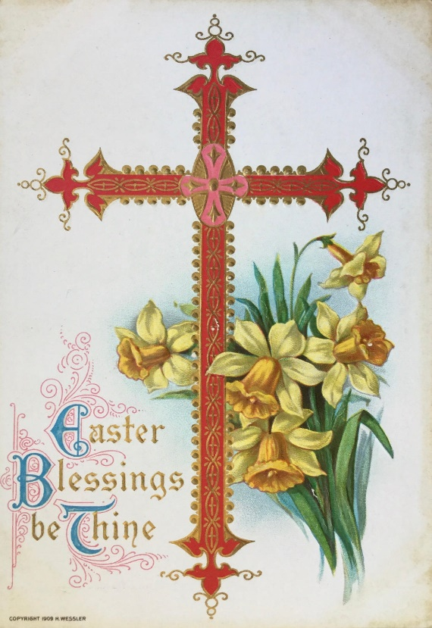
Meg our receptionist receiving her award from Pam
This Photo by Unknown Author is licensed under CC BY
for the most eggs found

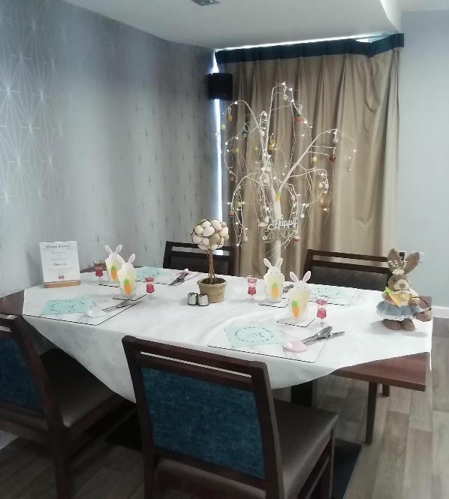
George was very eggcitted to receive his award
from Joan

Our tables already for a 3 course lunch

